Administrarea rețelelor de calculatoare

**Laboratorul 6**

1. **Diagram

   Description automatically generatedConfigurarea *Switch-ului nr 1* prin comand line**

1. **Configurarea *Switch-ului nr 2* prin comand line**

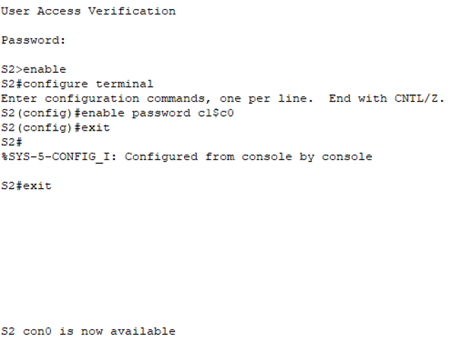

1. **Configurarea *Router-ului* prin comand line**

